Prepared by-Monil Gandhi 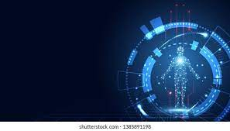

Task- Day 3 of LHD learn 3

Human Computer Interaction

* HCI (human-computer interaction) is the study of how people interact with computers and to what extent computers are or are not developed for successful interaction with human beings.
* A significant number of major corporations and academic institutions now study HCI. Historically and with some exceptions, computer system developers have not paid much attention to computer ease-of-use.
* Many computer users today would argue that computer makers are still not paying enough attention to making their products "user-friendly."
* However, computer system developers might argue that computers are extremely complex products to design and make and that the demand for the services that computers can provide has always outdriven the demand for ease-of-use.



* One important HCI factor is that different users form different conceptions or mental models about their interactions and have different ways of learning and keeping knowledge and skills (different "cognitive styles" as in.
* For example, "left-brained" and "right-brained" people). In addition, cultural and national differences play a part.
* Another consideration in studying or designing HCI is that user interface technology changes rapidly, offering new interaction possibilities to which previous research findings may not apply.
* Finally, user preferences change as they gradually master new interfaces.

 